**INDEX**

|  |  |  |  |
| --- | --- | --- | --- |
| **S.no.** | **Title** | **Page No.** | **Remarks** |
|  | Connect | 1 |  |
|  | Show all tables | 1 |  |
|  | Create new table in Database | 2 |  |
|  | Insert into table | 2 |  |
|  | Viewing Data in Tables | 3 |  |
|  | Eliminatedistinct rows | 4 |  |
|  | Sorting | 5 |  |
|  | UPDATE Contents of a table | 6 |  |
|  | MOIDFYING STRUCTURE OF TABLE:  Adding new columns, Modifying existing columns, Renaming table, DELETING ROWS, Delete all rows, Deleting Table | 8 |  |
| I/O Constraint: | | | |
|  | Primary Key | 12 |  |
|  | Foreign Key | 12 |  |
|  | Unique Key | 14 |  |
| Business Rule Constraint | | | |
|  | Not Null | 15 |  |
|  | Creating View: | 16 |  |
|  | Renaming Column of a view | 17 |  |
|  | Updating views: insert, update and delete | 18 |  |
|  | Dropping view | 19 |  |
| PL/SQL | | | |
|  | Program to find greatest among three | 20 |  |
|  | Program to print 1 to 10 using while loop | 22 |  |
|  | Program to print factorial of a number | 23 |  |
|  | Program to print 1 to 10 using for loop | 25 |  |
|  | Program to print if number is even or odd using goto statement. | 26 |  |
|  | Program to print if number is positive or negative. | 27 |  |
|  | Program to debit an amount of Rs. 2000 from account if the account has a minimum balance of 500 after the amount is debited. | 29 |  |
|  | Calculating and storing value of areas varying from radius 3 to 7 into table Areas. | 32 |  |
|  | If the price of product ‘P00001’ is less than 4000, then change the price to 4000. The price change is to be recorded in the old_price_table along with the product_no and the date on which the price was last changed. | 34 |  |
|  | Implicit Cursors | 37 |  |
|  | Explicit Cursors | 39 |  |
|  | Triggers | 41 |  |
|  | Standalone Procecdures | 43 |  |
|  | Procedures IN OUT program | 44 |  |
|  | Function to find factorial | 45 |  |

**SQL Queries**

**Connect:**

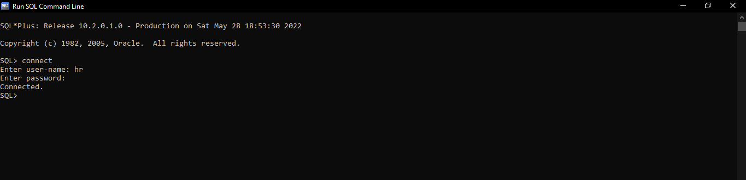

**Show all tables:**

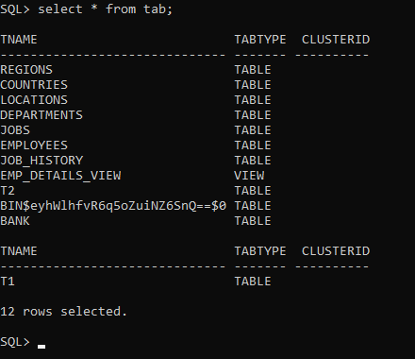

**Create new table in Database:**

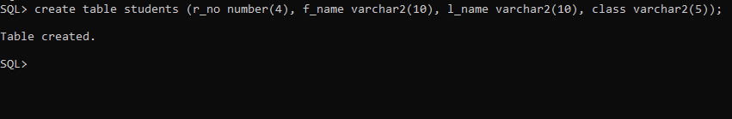

**Insert into table:**

//1st way:

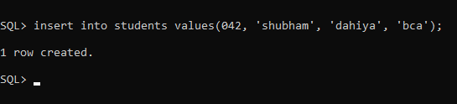

//2nd way:

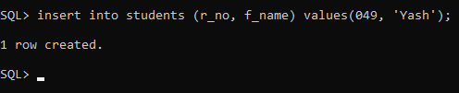

**Viewing Data in Tables:**

// all rows and columns

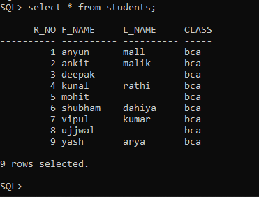

// selected rows, all colums;

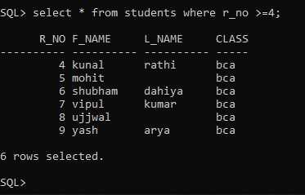

// selected columns and all rows;

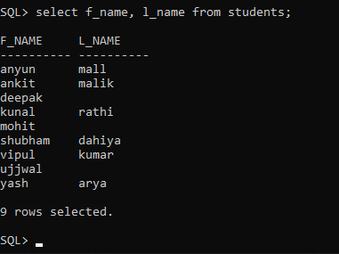

// selected rows and selected columns;

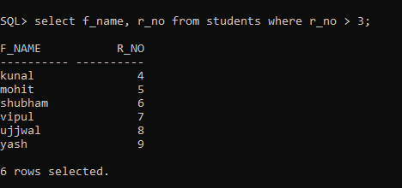

**Eliminate distinct rows:**

First creating duplicate row

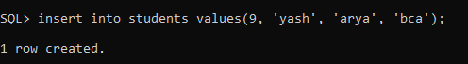

Now eliminating duplicate row

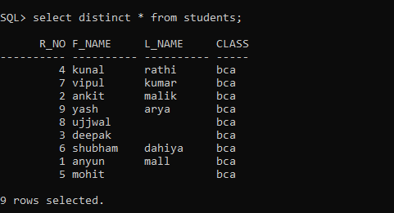

**Sorting:**

//Ascending by r_no, then by f_name

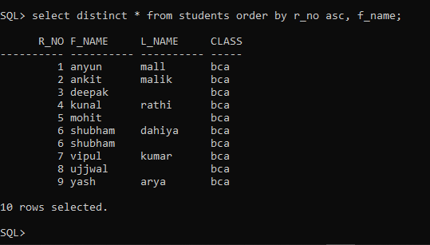

//Descending by r_no, then by f_name

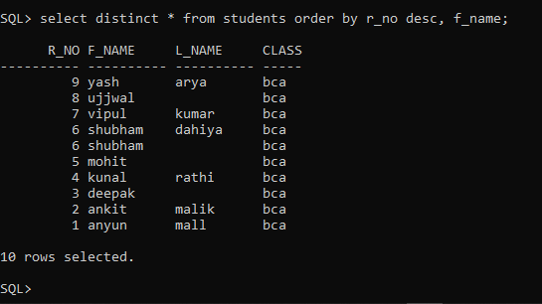

**UPDATE Contents of a table:**

Update all rows ( class from ‘bca’ to ‘B.C.A’ )

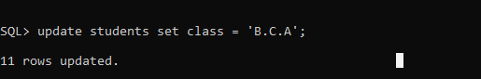

**Output:**

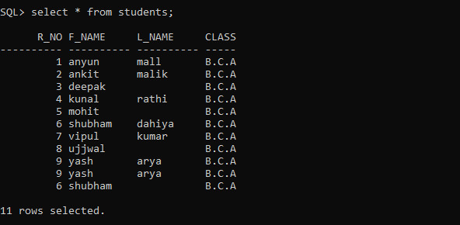

Update records conditionally ( from ‘bca’ to ‘B.C.A’ )

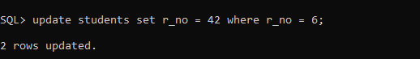

**OUTPUT:**

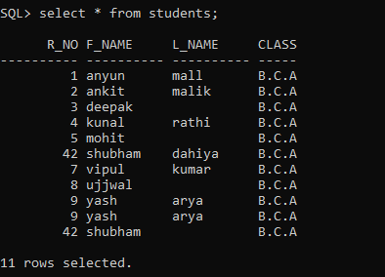**herer**

**MOIDFYING STRUCTURE OF TABLE**

**Adding new columns**

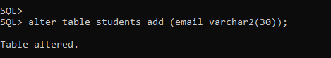

**OUTPUT:**

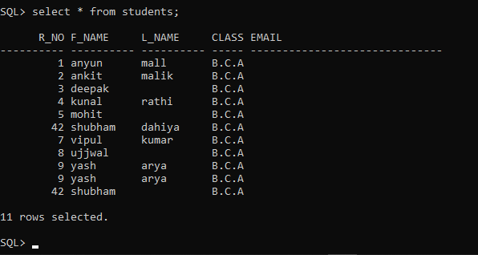

**Modifying existing columns**

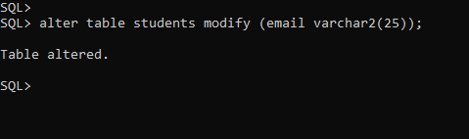

**OUTPUT:**

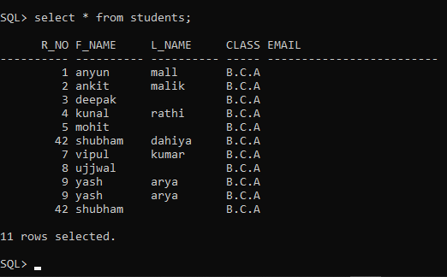

**Renaming table**

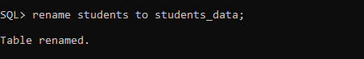

**DELETING ROWS**

Deleting duplicate r_no = 42 with l_name = null;

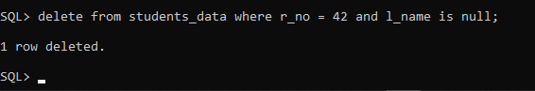

**OUTPUT:**

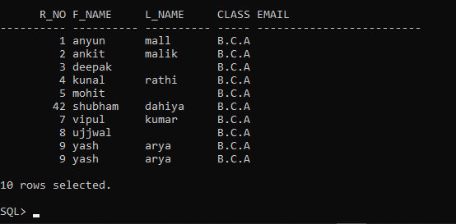

**Delete all rows**

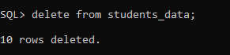

**OUTPUT:**



**Deleting Table**

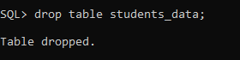

**OUTPUT:**

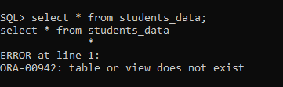

**DATA CONSTRAINTS**

Two types:

* I/O Constraint
* Business Rule Constraint

**I/O Constraint:**

* **Primary Key**

Two ways to create primary key – at column level, at table level;

*-Column level*



-*Table level*

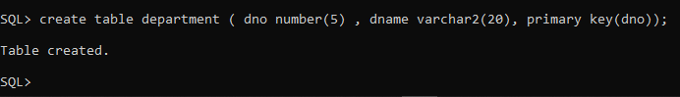

* **Foreign Key**

Columns whose value are derived from primary key

Two ways to create primary key – at column level, at table level;

***-Column level:***

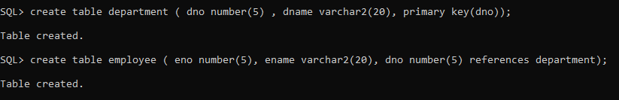

***Table Level***

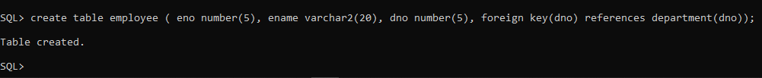

**OUTPUT:**

*Department table;*

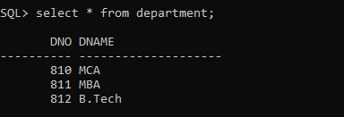

*Employee table;*

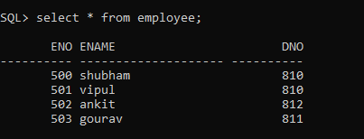

*Error on inserting inserting values out of dno range in employee table;*

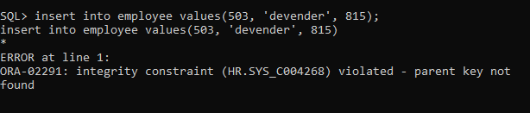

* **Unique Key**

*-Column level*

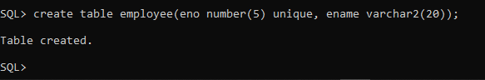

-*Table level*

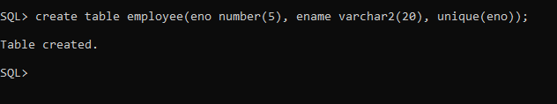

**OUTPUT:**

*Error on inserting duplicate ENO;*

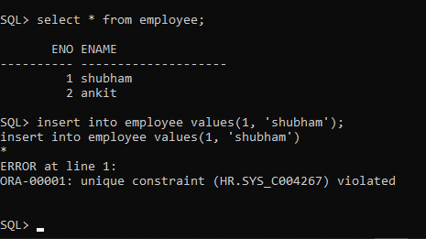

**Business Rule Constraint**

**Not Null**

Only applied at column level

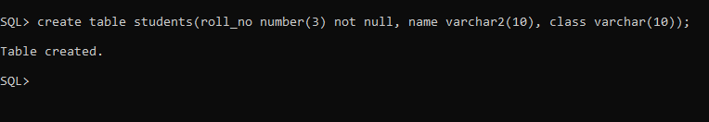

**OUTPUT**:

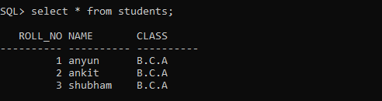

*Error on inserting null values in not null column*

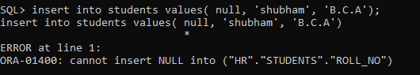

**Views**

*Customers table:*

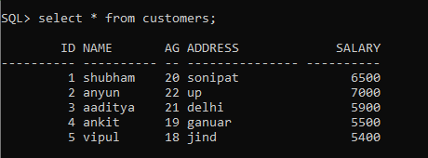

**Creating View:**



**OUTPUT:**

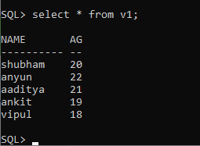

**Renaming Column of a view:**

*Renaming name column to f_name for view:*

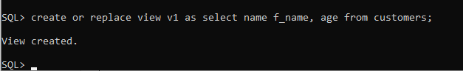

**OUTPUT:**

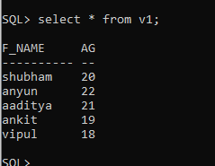

**Updating views:**

For updating views, the primary key + all not null must be included in the view.

**Insert command**

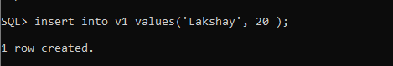

**Update command**

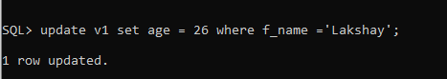

**OUTPUT:**

**Customers table:**

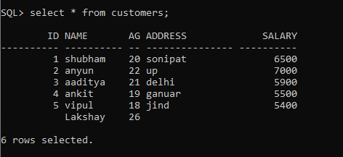

**Delete command:**

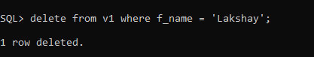

**OUTPUT:**

**Customers table:**

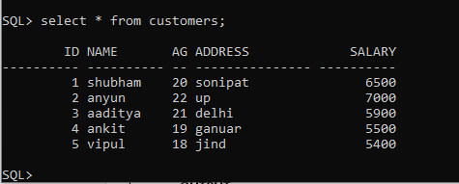

**Dropping view:**

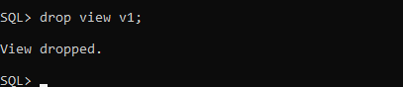

**PL/SQL**

**Problem Statement:**

**Program to find greatest among three**

**Program:**

declare

a number;

b number;

c number;

begin

a := &a;

b := &b;

c:= &c;

dbms_output.put_line(' ----- ---- --- -- ');

if a>b then

if a>c then

dbms_output.put_line('a is greatest');

else

dbms_output.put_line('c is greatest');

end if;

else

if b>c then

dbms_output.put_line('b is greatest');

else

dbms_output.put_line('c is greatest');

end if;

end if;

end;

**OUTPUT:**

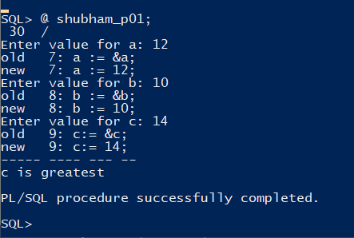

**Problem Statement:**

**Program to print 1 to 10 using while loop**

***Program:***

declare

i number;

begin

i := 1;

while i<=10

loop

dbms_output.put_line(i);

i:= i+1;

end loop;

end;

**OUTPUT:**

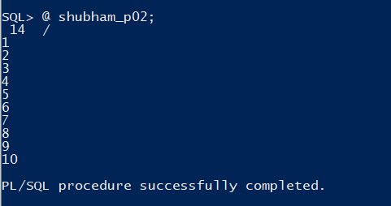

**Problem Statement:**

**Program to print factorial of a number**

***Program:***

declare

num number;

result number;

begin

result := 1;

num := &num;

while num > 0

loop

result := result * num;

num := num - 1;

end loop;

dbms_output.put_line('----------------------------------');

dbms_output.put('factorial: ');

dbms_output.put_line(result);

end;

**OUTPUT:**

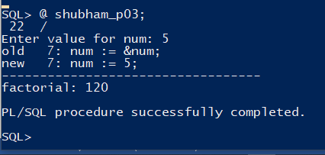

**Problem Statement:**

**Program to print 1 to 10 using for loop**

***Program:***

begin

for i in 1..10

loop

dbms_output.put_line(i);

end loop;

end;

**OUTPUT:**

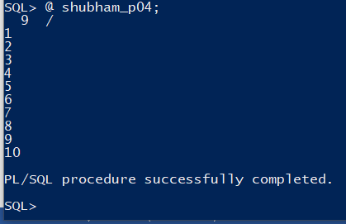

**Problem Statement:**

**Program to print if number is even or odd using goto statment;**

***Program:***

declare

num number;

begin

num := &num;

if mod(num,2) = 0 then

goto even;

else

goto odd;

end if;

<<even>>

dbms_output.put_line('num is even');

goto programend;

<<odd>>

dbms_output.put_line('num is odd');

<<programend>>

dbms_output.put_line('----------------------');

end;

**OUTPUT:**

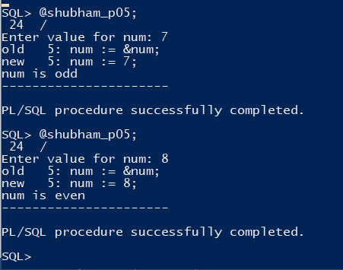

**Problem Statement:**

**Program to print if number is positive or negative**

***Program:***

declare

num number;

begin

num := &num;

if num > 0 then

dbms_output.put_line( ' num is positive');

else

dbms_output.put_line( ' num is negative');

end if;

end;

**OUTPUT:**

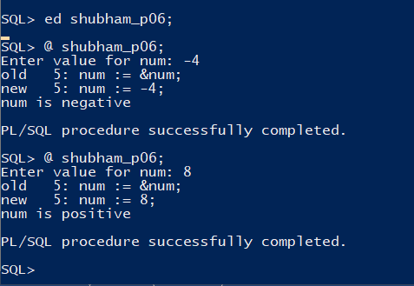

**Problem Statement:**

**Write a PL/SQL code block that will accept an account number from the user and debit an amount of Rs. 2000 from the account if the account has a minimum balance of 500 after the amount is debited. The process is to be fired on the Accounts table**.

***Program:***

declare

acc_no accounts.acc_id%type;

balance accounts.balance%type;

begin

acc_no := '&acc_no';

select balance into balance from accounts where acc_id = acc_no;

if balance >=2500 then

update accounts set balance = balance - 2000 where acc_id = acc_no;

dbms_output.put_line('Rs.2000 debited from Acc_Id: ' || acc_no );

else

dbms_output.put_line('amount not debited. Account balance must be above Rs.2500');

end if;

end;

**OUTPUT:**

*Initially accounts table*

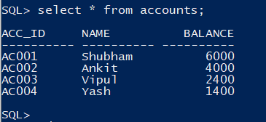

*After program execution for AC002*

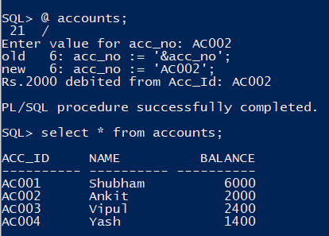

*After program execution for AC002 again*

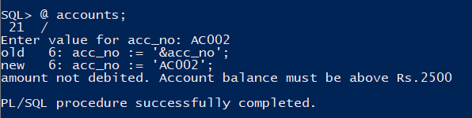

*After program execution for AC004*

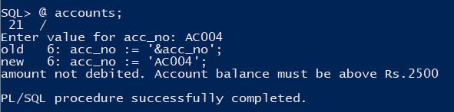

*After program execution for AC001*

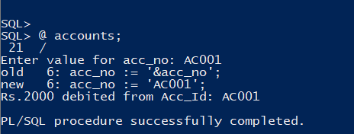

*Table Output:*

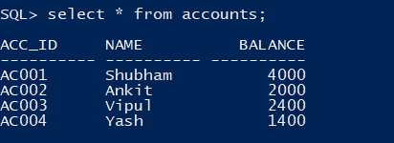

**Problem Statement:**

**Write a PL/SQL code block to calculate the area of a circle for a value of radius varying from 3 to 7. Store the radius and the corresponding values of calculated area in a table, Areas.**

***Program:***

declare

pi constant number(4,2) := 3.14;

r areas.radius%type;

a areas.area%type;

begin

r:= 3;

while r<=7

loop

a := pi * power(r, 2);

insert into areas values(r, a);

r:= r+1;

end loop;

end;

**OUTPUT:**

*Before areas table;*



*After executing program*

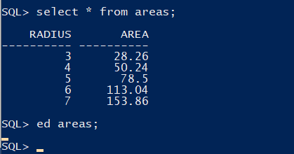

**Problem Statement:**

**Write a PL/SQL block of cod to achieve the following: If the price of product ‘P00001’ is less than 4000, then change the price to 4000. The price change is to be recorded in the old_price_table along with the product_no and the date on which the price was last changed.**

***Program:***

declare

product_noo product_master.product_no%type;

product_pricee product_master.sell_price%type;

old_price number(6);

begin

product_noo := '&product_noo';

select sell_price into old_price from product_master where product_no = product_noo;

dbms_output.put_line('old_price: ' || old_price);

if old_price < 4000 then

goto lessthen;

else

insert into product_master values(product_noo, product_pricee);

end if;

<<lessthen>>

update product_master set sell_price = 4000 where product_no = product_noo;

insert into old_price_table values(product_noo, sysdate, old_price);

dbms_output.put_line(' the price of product is 4000');

end;

**OUTPUT:**

*Product_master table:*

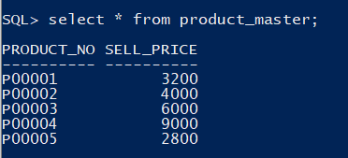

*Old_price_table:*

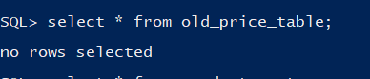

*Running program for ‘P00005’ & ‘P00001’*

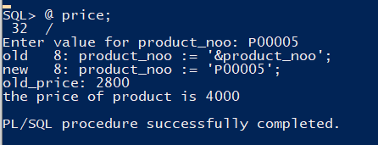

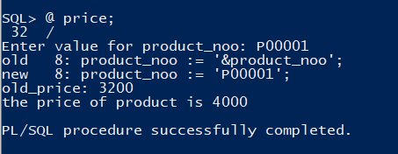

*Product_master table:*

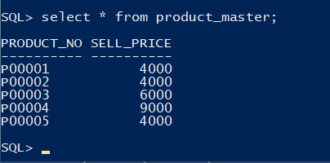

*Old_price_table*

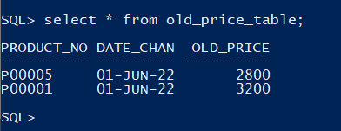

**Cursors**

Two types:

* Implicit Cursors
* Explicit Cursors

**Implicit Cursors:**

*Initially Customers table:*

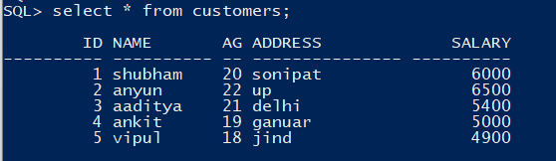

***Program to increment salary by 500:***

begin

update customers set salary = salary + 500;

if sql%notfound then

dbms_output.put_line('no records updated');

elsif sql%found then

dbms_output.put_line( sql%rowcount || ' rows updated');

end if;

end;

**OUTPUT:**

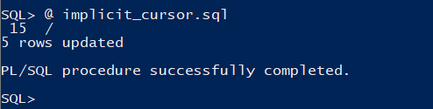

**Now customers table**

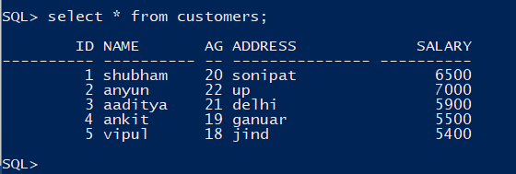

**Explicit Cursors:**

*Customers table*



*Program:*

declare

c_id customers.id%type;

c_name customers.name%type;

c_address customers.address%type;

cursor mycursor is select id, name, address from customers;

begin

open mycursor;

loop

fetch mycursor into c_id, c_name, c_address;

exit when mycursor%notfound;

dbms_output.put_line('id: ' || c_id ||' name: ' || c_name || ' address: ' || c_address );

end loop;

close mycursor;

end;

**OUTPUT:**

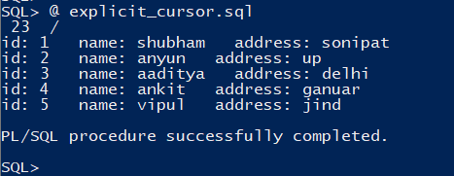

**Triggers**

***Customers table:***

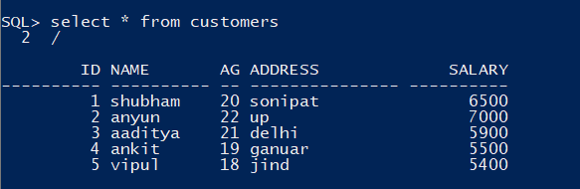

***trigger.sql Program:***

create or replace trigger salarydifference before delete or insert or update on customers for each row

declare

sal_diff number(7);

begin

sal_diff := :NEW.salary - :OLD.salary;

dbms_output.put_line('old salary: ' || :OLD.salary);

dbms_output.put_line('new salary: ' || :NEW.salary);

dbms_output.put_line('salary difference: ' || sal_diff);

end;

**OUTPUT:**

Inserting values

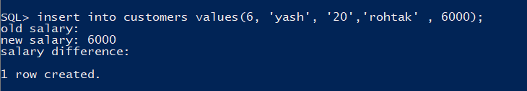

Updating values



Deleting values:

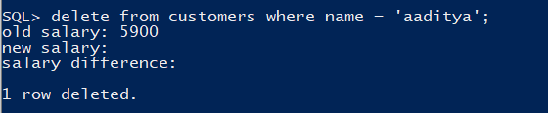

**Procedures & Functions**

**Standalone procecdures**

CREATE OR REPLACE PROCEDURE firstProcedure

AS

BEGIN

dbms_output.put_line('Hello Shuham!');

END;

**OUTPUT:**

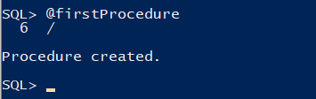

*Executing firstProcedure*

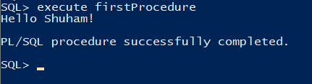

**Deleting Standalone Procedure**

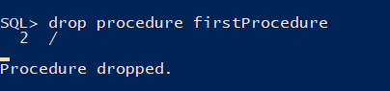

**IN OUT MODE in Procedures**

DECLARE

a number;

b number;

c number;

PROCEDURE findMin(x IN number, y IN number, z OUT number) IS

BEGIN

IF x < y THEN

z:= x;

ELSE

z:= y;

END IF;

END;

BEGIN

a:= 23;

b:= 45;

findMin(a, b, c);

dbms_output.put_line(' Minimum of (23, 45) : ' || c);

END;

**OUTPUT:**

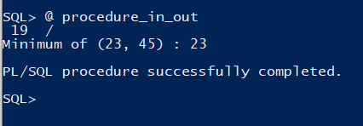

**Function to find factorial**

DECLARE

num number;

factorial number;

FUNCTION fact(x number)

RETURN number

IS

f number;

BEGIN

IF x=0 THEN

f := 1;

ELSE

f := x * fact(x-1);

END IF;

RETURN f;

END;

BEGIN

num:= 6;

factorial := fact(num);

dbms_output.put_line(' Factorial '|| num || ' is ' || factorial);

END;

**OUTPUT:**

